No Lighting (Unlit rendering)

📘 Definition
# Source: AI Source: Provided by: [Data Path: Persons Table -> ID Column: 1, Name_En Column: Motasem Essam] -> From: [ChatGPT] on [5/2/2026]
No Lighting (also called Unlit rendering) is a graphics mode where objects are shown without any lighting effects. This means there is:
- ❌ No shadows
- ❌ No highlights
- ❌ No shading
- ❌ No brightness changes from light sources
The object appears with a flat, constant color or texture.

🎨 How No Lighting looks
# Source: AI Source: Provided by: [Data Path: Persons Table -> ID Column: 1, Name_En Column: Motasem Essam] -> From: [ChatGPT] on [5/2/2026]
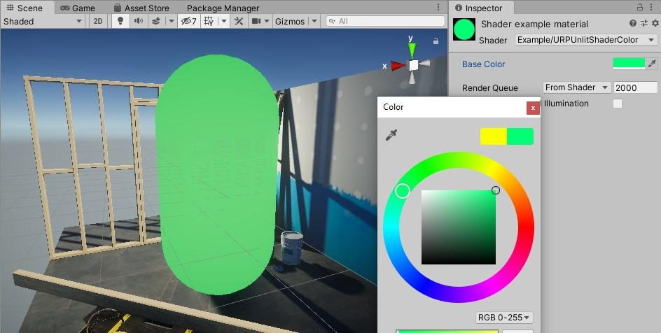
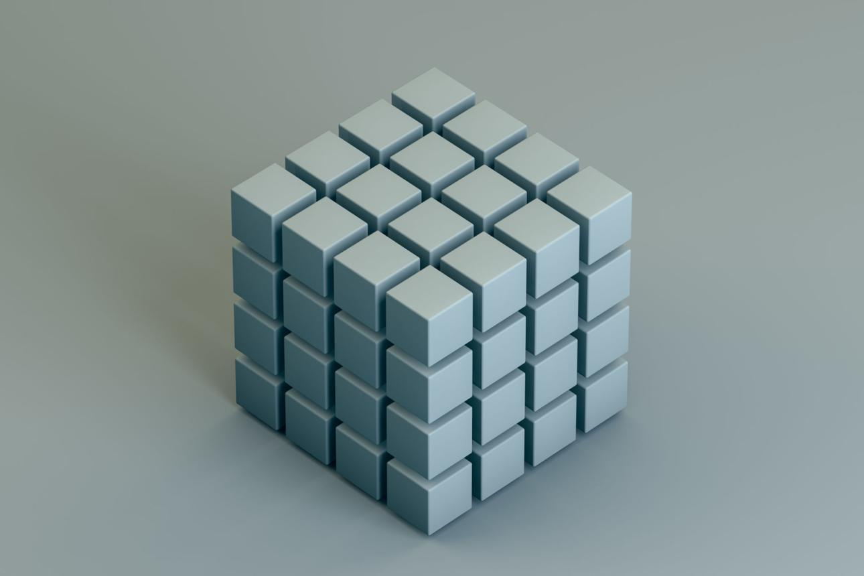
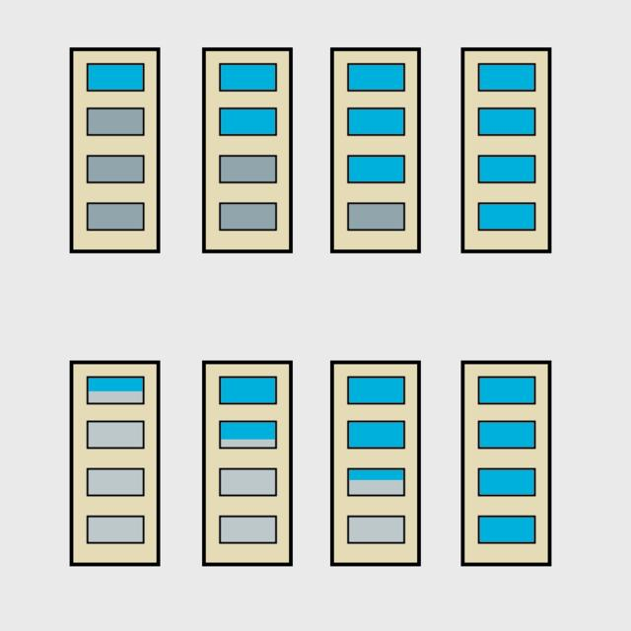
- Every part of the object has the same color
- Lighting does not affect appearance
- Looks flat, like a sticker or icon

🧠 Simple example
# Source: AI Source: Provided by: [Data Path: Persons Table -> ID Column: 1, Name_En Column: Motasem Essam] -> From: [ChatGPT] on [5/2/2026]
Think of:
- 📱 App icons → same color everywhere
- 🧊 A cube drawn with flat color (no shadow or shine)
- 🎮 Debug mode in games where lighting is turned off

🎮 Where No Lighting is used
# Source: AI Source: Provided by: [Data Path: Persons Table -> ID Column: 1, Name_En Column: Motasem Essam] -> From: [ChatGPT] on [5/2/2026]
- 🧑‍💻 User interfaces (UI elements)
- 🎮 Game debugging (to see models clearly)
- 🗺️ 2D graphics or stylized games
- ⚡ Performance optimization (faster rendering)

⚙️ Key features
# Source: AI Source: Provided by: [Data Path: Persons Table -> ID Column: 1, Name_En Column: Motasem Essam] -> From: [ChatGPT] on [5/2/2026]
- 🎨 Flat, constant color
- 🚫 No light interaction
- ⚡ Very fast to render
- 🧩 Used for non-realistic or UI visuals

🚀 In short:
# Source: AI Source: Provided by: [Data Path: Persons Table -> ID Column: 1, Name_En Column: Motasem Essam] -> From: [ChatGPT] on [5/2/2026]
No Lighting = a rendering mode where objects are shown with flat color and no light effects like shadows or highlights.

